Calculate the mean, skewness, variance and kurtosis of the bispectrum magnitudes.

For a random variable $X$:

Mean:

$$μ_{X}=E\left[X\right]$$

Variance:

$$σ_{X}=E\left[{\left(X-μ_{X}\right)}^{2}\right]$$

Skewness:

$$γ_{X}=E\left[{\left(\frac{X-μ_{X}}{σ_{X}}\right)}^{3}\right]$$

Kurtosis:

$$κ_{X}=E\left[{\left(\frac{X-μ_{X}}{σ_{X}}\right)}^{3}\right]$$

Synthetic Isabella 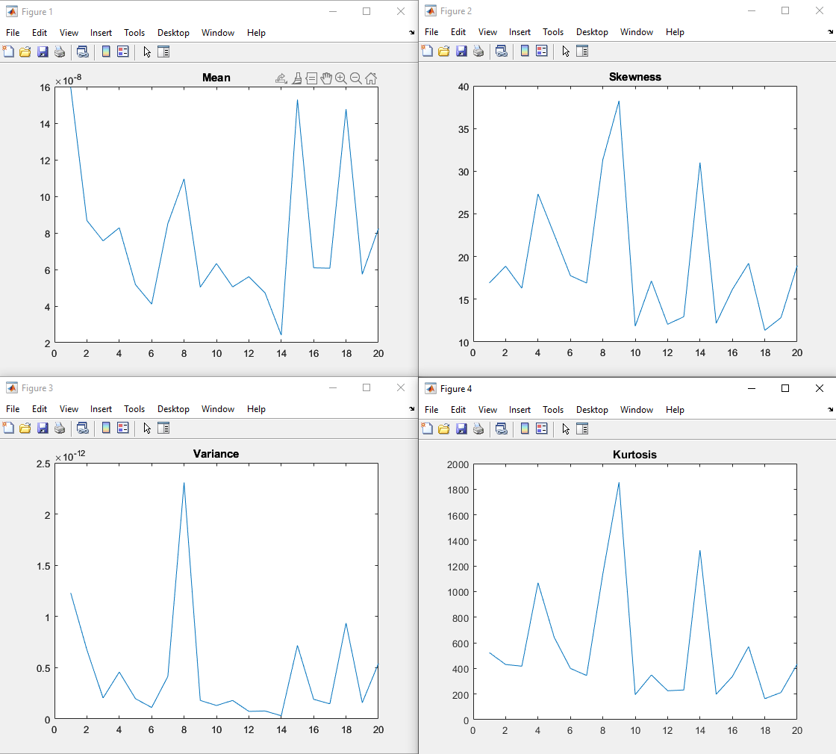

Synthetic Nick

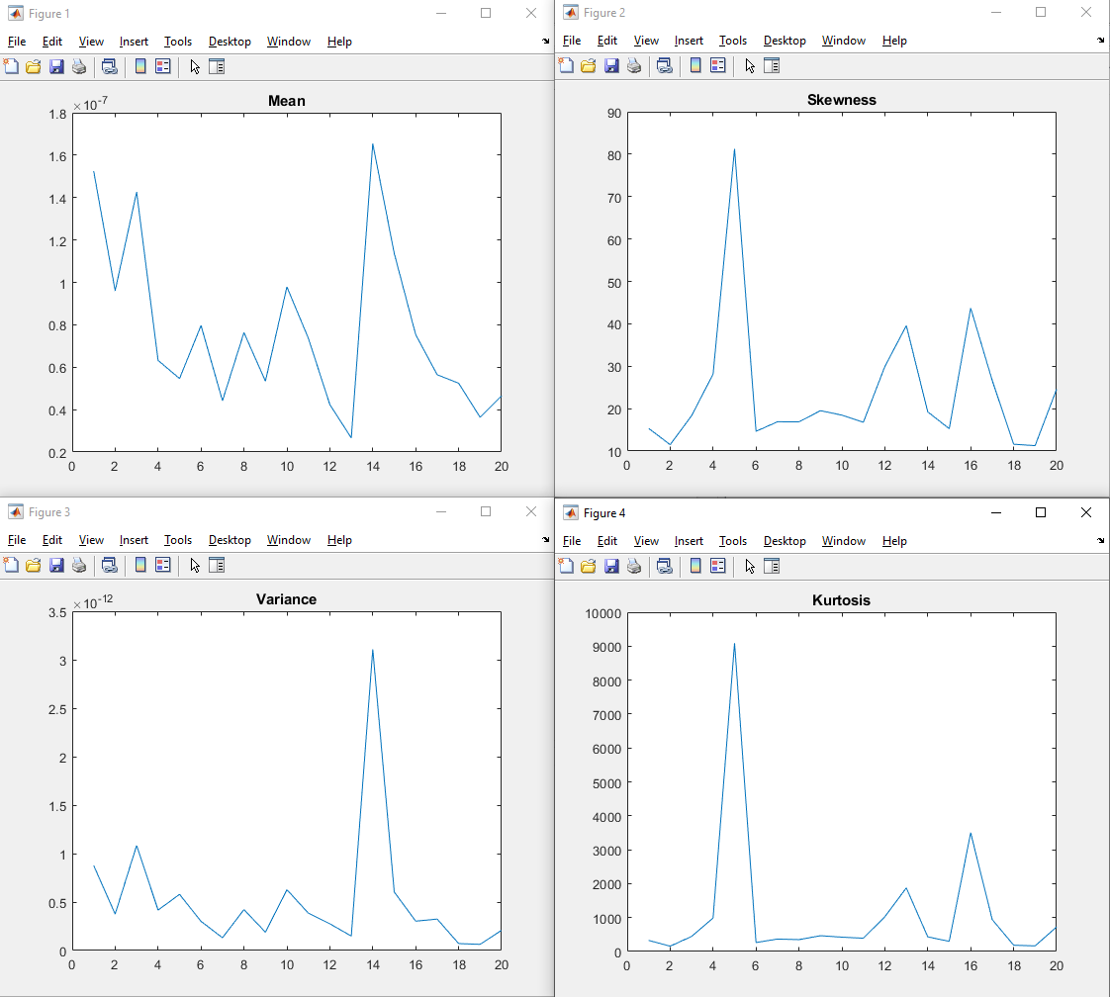

Natural Nick

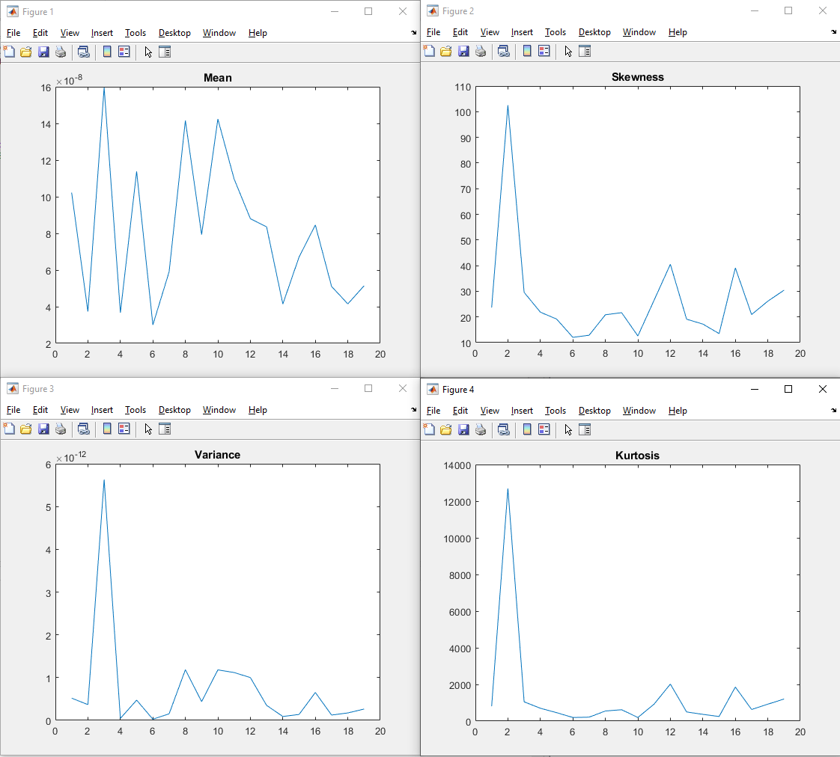

Natural Isabella

